Treatment Effectiveness for ADHD in College Students
Anna M. Hagan
Minnesota State University, Mankato
PSYC 211W

Treatment Effectiveness for ADHD in College Students

Introduction
This study examines the percentage of college students with Attention-Deficit Hyperactivity Disorder that have sought out a form of treatment, as well as the effectiveness of the sought-out treatment. Attention-Deficit Hyperactivity Disorder, also known as ADHD, is defined as “a developmental disorder characterized by distractibility, hyperactivity, impulsive behaviors, and the inability to remain focused on tasks or activities” (Davidson, Odle, & Cataldo, 2011, p. 253). The diagnosis of ADHD is highly common in today’s society. Common forms of treatment for ADHD are prescription medications and counseling. ADHD is mainly associated with the inability to focus, which means it potentially makes college tasks such as completing homework, attending lectures, and studying for exams very difficult for the individual. The aim of this study was to evaluate the effectiveness of overall treatment for ADHD; specifically, whether prescription drugs or counseling is more effective.
ADHD is the most commonly diagnosed disorder for children (Dakwar, Levin, Olfson, Wang, Kerridge, & Blanco, 2014, p. 1465). However, ADHD is still prominent in late adolescence and emerging adulthood. According to the American Psychiatric Association [DSM-IV-TR, 2000], ADHD affects between 3% and 7% of school-aged individuals and between 2% and 4% of adults. A 2014 study, (Kirsch, Doerfler, and Truong) found that ADHD is one of the most discussed disorders by counseling centers in colleges. This study looked at diagnostic and psychotropic medication prescriptions among college students as well as the number of students that were referred by college counseling centers to receive psychopharmacologic evaluation (Kirsch, et al., 2015). Students from several college institutions self-reported their measures of depression, anxiety, suicidal ideation/attempts, substance use, and other mental disorders. The results of this study found that depression, anxiety, and ADHD were the most prevalent psychiatric issues that were identified in the college students (Kirsch, et al., 2015). Specifically, 25% of the students were diagnosed with anxiety disorders, 12% were diagnosed with ADHD, and 12 % were diagnosed with substance use disorders (Kirsch, et al., 2015).
Furthermore, having ADHD means dealing with a number of psychosocial challenges such as “increased personal conflict, unintentional injuries, impaired driving, substance use, low educational attainment, occupational impairment, and criminal involvement” (Dakwar, et al., 2014, p. 1464). ADHD makes it more difficult for students to succeed in educational and workplace environments. A study conducted by Kuriyan, et al. (2013) suggests that educational and occupational fulfillment is higher for adults that have not been diagnosed with ADHD as a child. This study compared young adults that were diagnosed with ADHD during childhood with young adults that were not diagnosed with ADHD regarding occupational and educational outcomes. The results demonstrate a significant group differences for almost all of the variables that were analyzed where educational and occupational attainment was lower for adults with ADHD compared to adults without ADHD. These results support the idea that interventions (treatments) are necessary for children that have been diagnosed with ADHD to reach full potential in college and in the work place (Kuriyan, et al., 2013).
With the difficulties that ADHD entails, specifically for college students, it is important that these students are able to find an effective treatment. Finding an effective treatment will allow students with ADHD to have the same educational and vocational opportunities as those that have not been diagnosed with ADHD. This study aims to provide insight as to whether or not college students with ADHD think treatment is effective. This study asked self-selected college students with ADHD to identify if they have sought out treatment (either prescription drugs or counseling) and if they think the treatment was effective. Here I predict that those who have been diagnosed with ADHD and have sought out treatment will rate the treatments as being at least moderately effective.

Methods
Participants
The participants of this study were 51 (12 female and 39 males) self-selected college students from Minnesota State University, Mankato. All students were asked to complete the same survey via SONA.
Materials
Qualtrics was used to design the survey that was used for this study. SONA was used to distribute the survey to college students. The survey consists of demographic questions, questions regarding diagnosed disorders, questions regarding each specific diagnosis, and questions about treatments for the diagnosis.
Procedure
Self-selected participants had to sign in to SONA and complete the survey. They were asked a series of questions regarding the mental disorders they have been diagnosed with. After the survey closed, the responses were analyzed to identify possible relationships between the variables.
Statistical Analysis
The frequency was found for the number of students who completed the survey who have been diagnosed with ADHD. A chi-square test was used to see if there is a relationship between ADHD diagnosis and gender (male, female, or other). Significance was defined as p<0.05. Another chi-square test was performed to see if there is a significant difference in effectiveness of prescription drugs and effectiveness of counseling. Significance was defined as p<0.05. Lastly, a chi-square test was used to see if there was a relationship between students who have sought out prescription medication and effectiveness rating of prescription medication. Significance was defined as p<0.05.

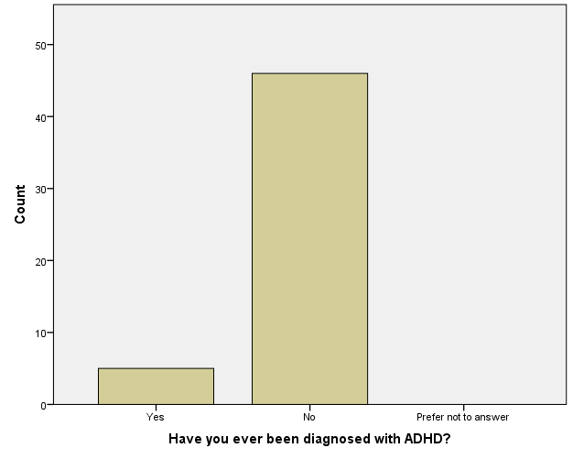
Results

The frequency of students who completed the survey that have been diagnosed with ADHD is N=5 or 9.8%.

Have you ever been diagnosed with ADHD? * Gender Crosstabulation
 |  | Gender |  | Total
 |  | Male | Female
Have you ever been diagnosed with ADHD? | Yes | 2 | 3 | 5
 | No | 10 | 36 | 46
Total |  | 12 | 39 | 51

The percentage of participants that have been diagnosed with ADHD did not differ by gender, X² (1, N=51) =.84, p=.36.

A chi-square test could not be conducted for the effectiveness of prescription drugs and effectiveness of counseling because only 1 participant selected that she received counseling as a form of treatment. However, she rated the counseling effectiveness to be a 3 out of 5 (moderately effective).
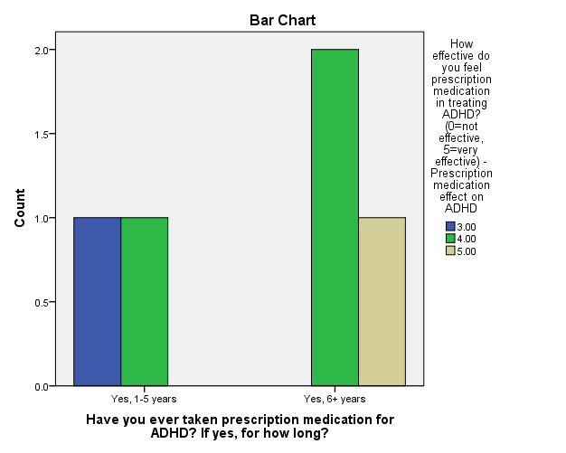

The chi-square test for students who have taken prescription medication and effectiveness rating of prescription medication showed that there is no significant difference, X2 (2, N=2) =2.22, p=.33.

Discussion

From the data that was collected, it can be concluded that around 10% of Minnesota State University, Mankato students have been diagnosed with ADHD. Furthermore, gender doesn’t seem to have a strong influence on whether or not the individual has been diagnosed with ADHD. A conclusion cannot be drawn about the effectiveness of prescription medication and the effectiveness of counseling because there was only one participant who received counseling as a form of treatment. However, it is important to note that the participant who received counseling, also received prescription medication. She rated the counseling a 3 out of 5 and the prescription medication as a 5 out of 5. Lastly, prescription medication is generally seen as at least moderately effective in the participants that completed this survey. However, due to lack of participants, this specific study shows no significant relationship between the number of students who have taken prescription drugs for ADHD and the effectiveness of it, so a general conclusion cannot be drawn from this data. The graph shows that all participants that have been diagnosed with ADHD (N=5), have received prescription drugs as treatment. Additionally, all of these participants gave the prescription medication a rating of at least a 3 out of 5.

The prediction of this study was that those participants who have been diagnosed with ADHD will rate the treatments that they have sought out as being at least moderately effective. The data gathered from this study show that the prediction is true. However, the statistical analyses show that there is no significant difference, and since the sample size of this study was so small, a general conclusion cannot be drawn for the entire population.

The findings of this study are relatively congruent with the findings of previous studies in regards to the percentage of college-aged students who have been diagnosed with ADHD. In a 2014 study conducted Kirsch, et al., 12% of the college participants had been diagnosed with ADHD. This study found that about 10% of the participants have been diagnosed with ADHD. Another study conducted in 2013 by Kuriyan, et. al. found results that indicate that treatments are necessary for people that have ADHD in order for them to have the same occupational and educational opportunities as those who have not been diagnosed with ADHD. In the current study, all of the participants that have used a form of treatment rated them to be at least moderately effective, which potentially indicates that sought out treatments have helped them in their college experience.
The current study mainly looked at the participants that have been diagnosed with ADHD. Out of the 51 total participants, only 5 of them had been diagnosed with ADHD. Because of the lack of participants that have been diagnosed with ADHD, there is also a lack of data. It is not sensible to draw general population conclusions from this data because of the sample size.
There is a lack of research on what aspects of ADHD counseling treatment affects. Future studies could examine exactly how counseling as a form of treatment affects individuals with ADHD. To further this study, a survey could be released specifically about ADHD and treatment methods for ADHD. Additionally, the survey could be released to several different universities instead of just one in order to obtain a larger sample size. By doing this, more data could be collected on individuals with ADHD and their experience with treatment methods. A larger sample size might reveal more significant group differences and relationships.
In conclusion, ADHD is very prevalent in today’s society, and it affects people of all ages. The psychological challenges of ADHD can potentially make college an incredibly difficult time for students that have been diagnosed with it. Students with ADHD have recognized treatment as being effective; therefore, students who have been diagnosed with ADHD should seek out treatment in order to have optimal opportunity for success.

References
American Pyschiatric Association. (2000). Diagnostic and statistical manual of mental disorders (4th ed., text rev.). Washington, DC.
Dakwar, E., Levin, F. R., Olfson, M., Wang, S., Kerridge, B., & Blanco, C. (2014). First treatment contact for ADHD: Predictors of and gender differences in treatment seeking. Psychiatric Services, 65(12), 1465-1473.
Davidson, T., Odle, T. G., & Cataldo, L. J. (2011). Attention Deficit Hyperactivity Disorder (ADHD). In J. L. Longe (Ed.), The Gale Encyclopedia of Children's Health: Infancy through Adolescence, 1, 253-259.
Kirsch, D. J., Doerfler, L. A., & Truong, D. (2015). Mental health issues among college students: Who gets referred for psychopharmacology evaluation? Journal of American College Health, 63(1), 50-56.
Kuriyan, A. B., Pelham Jr, W. E., Molina, B. S. G., Waschbusch, D. A., Gnagy, E. M., Sibley, M. H., Babinski, D. E., Walther, C., Cheong, J., Yu, J., & Kent, K. M. (2013). Young adult educational and vocational outcomes of children diagnosed with ADHD. Journal of Abnormal Child Psychology, 41(1), 27-41.

